**BSQL Assignment 202**

**Questions to answer**:

1. Create the tables (with the most appropriate/economic field/column constraints & types) and add at least 10 records into each created table

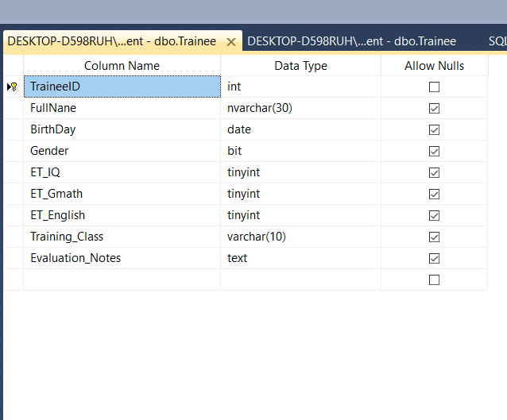

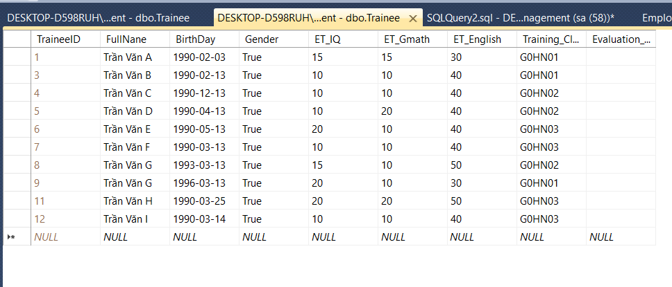

2. Change the table TRAINEE to add one more field named Fsoft_Account which is a not-null & unique field.

ALTER TABLE Trainee

ADD Fsoft_Account char(20) NOT NULL UNIQUE

3. Create a VIEW that includes all the ET-passed trainees. One trainee is considered as ET-passed when he/she has the entry test points satisfied below criteria:

1. ET_IQ + ET_Gmath >=20
2. ET_IQ>=8
3. ET_Gmath>=8

ET_English>=18​

CREATE VIEW ET_Passed_Trainees AS

SELECT TraineeID, FullNane, BirthDay, Gender

FROM Trainee

WHERE ET_IQ + ET_Gmath >= 20 AND ET_IQ >= 8 AND ET_Gmath >= 8 AND ET_English >= 18

4. Query all the trainees who are passed the entry test, group them into different birth months.

SELECT TraineeID,

FullNane,

BirthDay

FROM Trainee

WHERE ET_IQ + ET_Gmath >= 20

AND ET_IQ >= 8

AND ET_Gmath >= 8

AND ET_English >= 18

ORDER BY MONTH(BirthDay)

5. Query the trainee who has the longest name, showing his/her age along with his/her basic information (as defined in the table).

SELECT TraineeID,

FullNane,

BirthDay,

YEAR(GETDATE()) - YEAR(BirthDay) AS AGE,

Gender

FROM Trainee

WHERE LEN(FullNane) = (SELECT MAX(LEN(FullNane)) FROM Trainee)